Joseph Roberts

CS-250

7-1: Sprint Review and Retrospective

Dec. 09, 2024

**Sprint Review and Retrospective**

The SNHU travel project is aiming to expand its availability to its clients through the development of a website. This project would assist users with booking vacations based on specific preferences created by each user.

The roles required for this project consisted of a team of specialized individuals, who together managed and completed this project, the roles are as follows:

* Scrum Master: The Scrum Master helps the team by facilitating key Scrum events to improve efficiency and collaboration. They ensure the team is aligned and progressing towards goals, maintain a clear product backlog, and lead reviews to assess progress. Through retrospectives, they help the team reflect and identify ways to improve future sprints, fostering a productive and continually improving environment.
* Product Owner: The Product Owner maximizes product value by managing and prioritizing the product backlog. They align the development team's efforts with the project vision and adapt based on stakeholder feedback. Their role ensures the product meets user needs and achieves business goals.
* Tester: The Scrum Tester is responsible for ensuring the quality of the product by defining acceptance criteria, conducting various tests, and identifying defects. They work closely with developers throughout the sprint and automate tests to enhance efficiency. They also document and report issues, ensuring they are resolved quickly. By participating in reviews and retrospectives, the tester helps improve the testing process and overall sprint effectiveness.
* Developer: A Scrum Developer is a vital member of the team responsible for delivering potentially shippable product increments each sprint. They work closely with the Product Owner and Scrum Master, participating in planning, stand-ups, and reviews. Their tasks include writing and testing code to build features and resolve issues. By continuously refining tasks and improving processes, they contribute significantly to the team's success and the effectiveness of the Scrum framework.

Each member is responsible for their contribution but is also reliant on other members of the team, an example of this is when Brian (Tester) emailed Christy (Product Owner) about clarification on the user stories, he specialized in testing but relied on Christy for answers to complete his work. This also leads to how Agile completes User Stories, dividing the project into sprints enables the team to tackle small, manageable tasks, leading to the regular delivery of functional increments. Stakeholders provide continuous feedback during sprint reviews, allowing the team to adjust and refine the development process to stay aligned with user needs. Daily stand-ups enhance communication and expedite the resolution of any issues, ensuring that impediments are quickly addressed. This dynamic and adaptive approach ensures the efficient and timely completion of user stories while accommodating evolving user requirements.

Handling interruptions is always part of work and life, this can always slow things down for a moment but once you assess the situation and make a plan of action, the setback is minor and at times not noticeable. To handle interruptions in Agile, evaluate and prioritize the urgency of the interruption, addressing critical ones immediately while scheduling others for later. Allocate buffer time in sprints for unexpected tasks and add unplanned work to the backlog for proper prioritization. Use daily stand-ups to communicate interruptions and adjust plans, ensuring the team remains aligned and responsive. The SNHU team worked though this exact issue, Christy received news of a change in desired vacations and although the team were not planning on this, they held a meeting and gathered the needed information. The need for a change in a deadline was not required as agile allows for a change in priorities and this benefits the team greatly.

Communication is one of the most important things a team must have, if not THEE most important. I was assigned to a team for a group discussion, and we had to select roles, principles and come to a group agreement on what principles were vital to the team. This project was to be completed after a holiday so prior to the holiday, I sent an email to the members of the team to introduce myself and get a general idea of the team. It was decided to use Discord (a server-based chat network) to communicate, I already have a server, so I sent out invite links and within 24 hours everyone joined up. This course of action I believe was important on several points, 1) we were able to get to know each other and our aims, 2) we were able to assign roles early which gave us time to plan and execute, 3) the entire experience was great and allowed us to interact with each other personally, which is something that is limited with online classes. One member even said the chat experience was great and he was in the role of Product Owner, our Developer even was joking about how his discussion was last, just like the developers he works with. I believe we have a great team, and communication was key to this, and in any agile team this principle will always be key.

Below is an example of our teams communication and the effectiveness of team work.

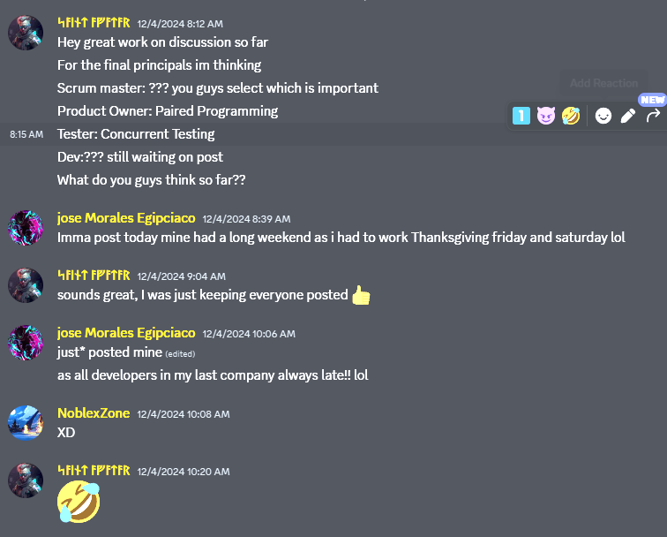

For the SNHU Travel project, Agile project-management tools like JIRA were invaluable in managing tasks and tracking progress. They provided a clear visual representation of both completed and pending work, helping the team stay organized and focused. Communication within the team was enhanced, as JIRA allowed for the sharing of ideas, tasks, and updates, ensuring everyone was well-informed. Automation features in JIRA streamlined repetitive processes, moving tasks through different statuses automatically, which sped up the workflow and reduced manual intervention. This resulted in higher efficiency, improved collaboration, and ultimately led to a successful outcome for the SNHU Travel project.

Throughout the SNHU project, the Scrum Agile approach proved both beneficial and challenging. A key advantage was our ability to quickly adapt to changes through user stories, which mitigated the risk of project failure due to unforeseen circumstances. This flexibility helped us maintain our focus on delivering value to end users while staying on track with the project plan. However, towards the end of the project, changes to vacation types caused some frustration among developers. Despite these challenges, the Scrum Agile approach fostered collaboration, innovation, and adaptability, which ultimately accelerated the completion of the customer-centric SNHU Travel project. While there were hurdles, Scrum Agile was the optimal choice for a dynamic and evolving project like SNHU Travel.